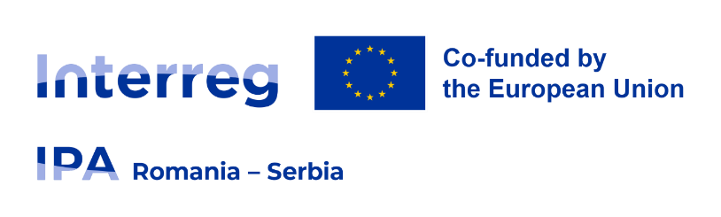

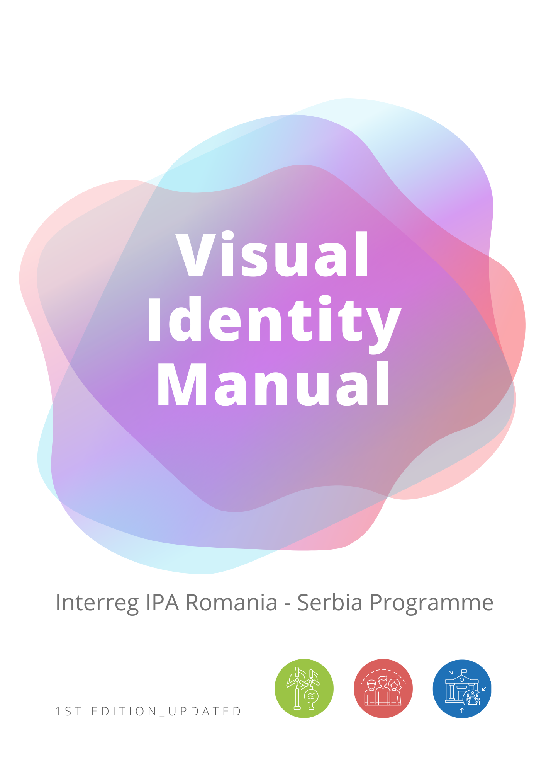

**Table of Contents**

**What is Interreg?** 4

**Introduction to the Visual Identity Manual** 5

**Role of information and publicity** 6

**Purpose of the Visual Identity Manual (VIM)** 6

**Responsibilities of the Lead Partner (LP)** 7

**Minimum visibility requirements** 9

**Programme name** 9

**The Interreg brand = Programme logo** 10

**Colours of the Programme logo** 11

**How to use the Programme logo** 12

**Size of the Programme logo** 13

**Language versions of the Programme logo** 14

**Typography of the Interreg IPA Romania-Serbia Programme** 16

**EU Cohesion Policy Objectives: Our Priority Icons** 17

**Plain language** 19

**Public speaking** 19

**Presentations** 20

**Events** 20

**Photographs** 22

**Advertisements** 24

**Social Media** 25

**Social media hash tagging** 25

**Social media tagging using @** 26

**Websites** 26

**Audio materials** 27

**Audio-visual materials/video spots/films** 27

**Publications, brochures, leaflets etc.** 28

**Information disclaimers** 29

**Technical section** 29

**Posters** 30

**Banners and roll-ups** 31

**Durable plaques or billboards (mandatory version)** 32

**Other touristic/outdoor signboards** 33

**Newsletters** 34

**Vehicle panels** 35

**Self-Adhesives/Stickers/Tags** 35

**Promotional items** 36

**Tender announcements for public procurements** 36

**Attendance certificates and diplomas** 36

**Green communication tips** 37

**Incorrect use of the brand** 38

**Visual Identity Manual**

**of the Interreg IPA Romania-Serbia Programme**

# **What is Interreg?**

The European Union promotes cooperation between regions and countries to help their economic and social development and tackle the obstacle of borders. European Territorial Cooperation (ETC), better known as Interreg, is one of the key instruments of the EU supporting cooperation across borders through project funding. Its aim is to jointly tackle common challenges and find shared solutions in different fields such as health, environment, research, education, transport, sustainable energy, border management and more.

Under the 2021-2027 financial allocation period, the Interreg is built around four strands to make cooperation happening everywhere in Europe and beyond, reinforcing cooperation with partner countries, with Interreg IPA, Interreg NEXT and the integration of a dedicated strand for cooperation between the EU outermost regions and neighbouring countries:

1. Cross-border (Interreg A)
2. Transnational (Interreg B)
3. Interregional (Interreg C)
4. outermost regions’ cooperation (Interreg D)

2021-2027 is the sixth period of Interreg and therefore it is called Interreg VI.

The Interreg IPA Romania-Serbia Programme is part of the Interreg VI A programmes funded by the European Union under the Instrument for Pre-accession Assistance (IPA III) and co-funded by the partner states of the Programme: Romania and Serbia.

# **Introduction to the Visual Identity Manual**

The purpose of this Visual Identity Manual is to offer support for communicators in presenting their valuable project results that have a real impact on the life of European citizens living in the Romanian-Serbian cross-border region.

The **Visual Identity Manual** (hereinafter referred to as „**VIM**”) contributes to the establishment of a coherent visual identity at all levels, using standardized communication tools and a **logo**. The rules are applicable for all projects implemented under the **Interreg IPA Romania-Serbia Programme** (hereinafter referred to as „**Programme**”).

Project partners and contracted designers must respect requirements regarding the visual identity of the European Union flag and the Interreg branding. The Visual Identity Manual of the Interreg IPA Romania-Serbia Programme may be updated following European Commission recommendations or independently based on technical implementation needs. The **updated version** of the Visual Identity Manual of the Programme is available accessing: [www.romania-serbia.net](http://www.romania-serbia.net)

**Always check the latest version of the VIM before preparing your visibility and communication materials.**

Independently, the Authorities of the Programme may offer various support and information regarding the implementation of the Programme on their institutional websites:

|  |  |  |
| --- | --- | --- |
| **Level of Authority** | **Institution** | **Website** |
| **European Commission** (EC) | European Commission | <http://ec.europa.eu/> |
| **Managing Authority** (MA) | Ministry of Development, Public Works and Administration | https://www.mdlpa.ro/ |
| **National Authority** (NA)  Joint Secretariat Antenna Zrenjanin  (JS Antenna Zrenjanin) | Ministry of European Integration, Republic of Serbia | https://www.mei.gov.rs/ |
| **Joint Secretariat** (JS)  **First Level Control Unit** (Romania)  (FLCU Romania) | Regional Office for Cross-border Cooperation Timisoara  (RO CBC Timișoara or BRCT Timisoara) | <http://www.brct-timisoara.ro/> |
| **First Level Control Unit** (Serbia) | Ministry of European Integration, Republic of Serbia | https://www.mei.gov.rs/ |

# **Role of information and publicity**

Communication should be an integrated part of every project, because successful communication activities contribute to the success of the project implementation.

Information and publicity activities regarding the funds available under the Interreg IPA Romania-Serbia Programme focus on increasing the level of information, awareness and transparency concerning the overall implementation of the Programme.

General principles of information and publicity activities under Interreg IPA Romania-Serbia Programme:

▪ Transparency: the ability to offer in time objective and clear information;

▪ Efficiency: the optimal use of resources to achieve maximum impact;

▪ Responsibility: the public interest will be in the centre;

▪ Flexibility: fast adaptation to changes;

▪ Political neutrality: neutral position regarding politicians and politics;

# **Purpose of the Visual Identity Manual (VIM)**

The purpose of the VIM is to employ standardized communication tools and a coherent set of rules for implementing the information, publicity and visibility requirements in the Projects funded through the present Programme.

The Lead Partner bears the responsibility on the project level for informing the public about the funding obtained from the European Union, but every Project Partner is responsible for implementing the communication activities, according to the information and publicity activities planned during the implementation of the project.

**It is recommended to appoint a person responsible for the implementation of information and communication measures at project level.** Projects have to ensure that their final outputs have clear reference to EU contribution, while **Interreg IPA Romania-Serbia Programme logo** (which includes the EU flag) **is mandatory to be used**. No other visual identity or logo must be used to highlight the support from the EU.

**Mandatory to have in your project:**

✓ ensure that project final outputs have clear reference to EU contribution by including the Programme logo;

✓ durable plaques or billboards – details in the dedicated section.

In accordance with the EU Regulation 1059/2021 on specific provisions for the European territorial cooperation goal (Interreg) supported by the European Regional Development Fund and external financing instruments.

Article 36: **Responsibilities of managing authorities and partners with regard to transparency and communication:**

**The project partners shall ensure the visibility of the Union funding, in particular when promoting the actions and their results, by providing coherent, effective and targeted information to multiple audiences, including the media and the public.**

Where remedial actions have not been put into place, **the managing authority shall apply measures**, taking into account the principle of proportionality, **by cancelling up to 2% of the support from the funds**.

# **Responsibilities of the Lead Partner (LP)**

**The Lead Partner** shall ensure that communication and visibility materials realized by the project **are made available upon request** to programme bodies, Union institutions, bodies, offices or agencies and that a **royalty-free**, **non-exclusive** and **irrevocable licence to use such material and any pre-existing rights attached to it is granted to the Union, following point 2 from Annex IX of CPR Regulation 2021/1060**.

**The Lead Partner is responsible for informing the Joint Secretariat regarding the information and publicity measures taken to promote the projects funded under the Programme.**

The Lead Partner must inform and must ensure that all project partners inform the public, using the measures laid down in Annex IX of Regulation (EU) no.1060/2021, about the assistance obtained from the Programme.

The Lead Partner and all project partners are responsible for implementing the information and publicity activities related to the non-reimbursable financial assistance received through the programme.

The Lead Partner must ensure and must satisfy itself that all project partners ensure transparency and accurate information to the mass media on the projects funded under the Programme.

All information and publicity actions developed by the project partners (including the Lead Partner) must observe the Visual Identity Manual (available on the programme website: www.romania-serbia.net or on request at the Joint Secretariat).

For all information and publicity actions developed by the project partners, the Lead Partner must ensure that they archive in a single place (hard copy and/or electronically) the documents related to these activities (for example, information and publicity materials they produced, printed materials, audio-video materials).

By accepting the funding, the LP and its partners give their acceptance for their inclusion in the list of operations published following Article 36(3) of Regulation (EU) no. 1059/2021, respectively Article 49(3) of Regulation (EU) no. 1060/2021.

The Lead Partner shall ensure the proper means of communication between the project and the programme including:

* + participation, whenever requested, in LP training organized by the Joint Secretariat;
  + participation, whenever requested, in other events organized by the Programme with the purpose of presenting/ discussing/ developing/ sharing project results and creating synergies with other projects and relevant organisations;
  + providing a visible link on the project partner’s website leading to the Programme website.

# **Minimum visibility requirements**

**During the implementation of an operation/project, all project partners shall inform the public about the support obtained from the European Union and the Interreg IPA Romania-Serbia Programme using written communication (text) and audio-visual communication.**

**The minimum visibility element that must be included in all visibility materials is the logo of the Interreg IPA Romania-Serbia Programme.**

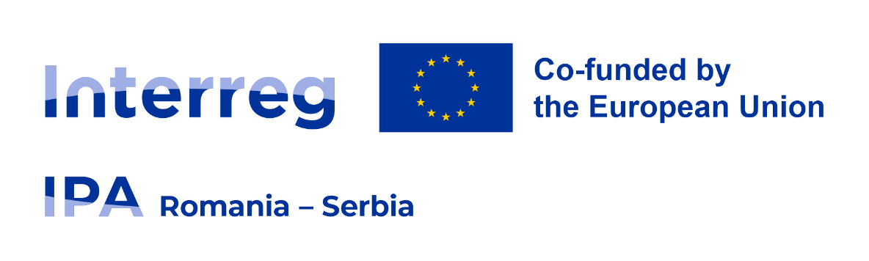

As a justified exception, where the promotional item or equipment is very small, the minimum visibility element you must include is the European Union emblem and the words "Co-funded by the European Union" (if possible). You will use the phrase in the language suitable to the main public you address (English, Romanian or Serbian).

# **Programme name**

**The name of the Programme is:**

Interreg IPA Romania-Serbia Programme

Programul Interreg IPA România-Serbia

Interreg IPA program Rumuniјa-Srbiјa

Интеррег ИПА програм Румунија-Србија

In public communication, do not use other names for the Interreg IPA Romania-Serbia Programme. **Compliance with provisions regarding the use of the programme name, namely the full as well as the short version, is compulsory.**

**Use the technical language** **and short terms carefully.**

Technical terms like ”IPA”, ”eligibility”, ”applicants”, ”MA”, ”NA”, ”JS”, ”FLC” or other terms may have a stressful lexical impact over the public.

# **The Interreg brand = Programme logo**

The Interreg brand is designed to provide a robust and easily recognizable identity that favours an easy combination with other logos in co-branding situations.

The brand consists of the following elements: the Interreg logotype (1) with the coloured arch inside, the EU emblem (2), the statement (3), the IPA logo type (4) and the name of the border area (5).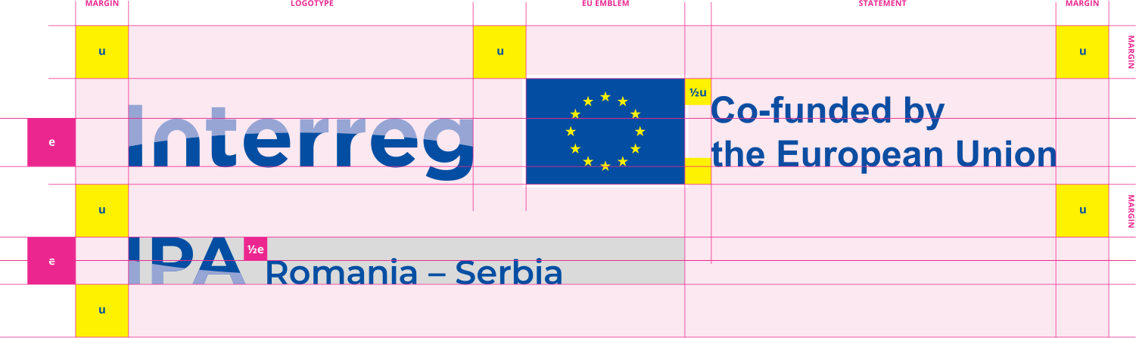

The brand is surrounded by a clear space area that defines the minimum distance to other elements such as other logos, pictures, texts or any other design elements. The elements of the brand represent a unit which is defined as invariable. The composition of the brand elements follows specific rules and must not be changed.

**Always use the digital brand files provided, and do not try to recreate or modify the brand in any way.**

# **Colours of the Programme logo**

The Programme logo colours are derived from the **EU flag official colours** and must not be changed (Reflex Blue and Yellow). Reflex Blue and Light Blue define the Interreg brand’s visual identity and should be used as the main colours in communication materials. Yellow can be used sparsely as an accent colour.

Reflex Blue

Colour

Light Blue

Colour

Yellow

Colour

**Reflex Blue**

C: 100, M: 80, Y: 0, K: 0

PANTONE Reflex Blue C

R: 0, G: 51, B: 153

Hexadecimal: 003399

**Yellow**

C: 0, M: 0, Y: 100, K: 0

PANTONE Process Yellow

R: 255, G: 204, B: 0

Hexadecimal: FFCC00

**Light Blue**

C: 41, M: 30, Y: 0, K: 0

PANTONE 2716

R: 159, G: 174, B: 229

Hexadecimal: 9FAEE5

***Pantone:*** *Spot colours*

**CMYK:** Process-colour printing, 100 colour gradations per channel

*C = cyan*

*M = magenta*

*Y = yellow*

*K = black*

**RGB:** Colour sample for monitor display with 256 gradations per channel

*R = red*

*G = green*

*B = blue*

**Hex:** System similar to RGB, but with gradations from “00” to “FF” (hexadecimal) per channel.

This system is suitable for designing websites.

**What type of colour codes to use?**

**CMYK**: printed materials (vector designs: flyers, brochures, posters);

**PANTONE**: spot colours for printings (textile printing);

**RGB**: electronic communication, Word documents, Internet, Web;

**Hexadecimal**: a base-16 numbering system used to define colours on Web pages.

|  |
| --- |
| **CMYK:** C = Cyan, M = Magenta, Y = Yellow, K = Black.  **RGB:** R = Red, G = Green, B = Blue.  **Hexadecimal:** System similar to RGB, with gradations from “00” to “FF” per channel. |

# **How to use the Programme logo**

Having in mind that the Interreg IPA Romania-Serbia Programme is part of Interreg family programmes, the Programme logo is designed as full brand integration with the Interreg programmes, including Interreg NEXT and other Interreg IPA programmes.

The Programme logo is the most important instrument for creating brand association in the visual communication for the Interreg IPA Romania-Serbia Programme, therefore, the logo shall be used only as mentioned in the present manual and must not be recreated differently under any circumstances.

**The standard Programme logo is the full colour version.** This version should always be the first option. Ideally the logo should be used on white or light backgrounds. For dark backgrounds the standard logo should include a white rectangle or you may choose the white & colour Programme logo. **White & Colour logo** is an **alternative** for dark backgrounds or for coloured backgrounds when using a white background box is not possible due to space restrictions, context, or because it would cover an important element of the background image.

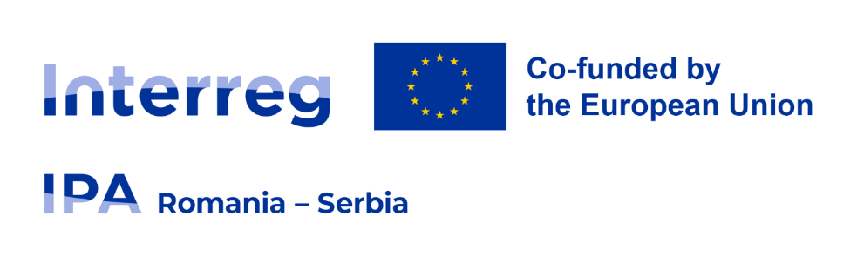

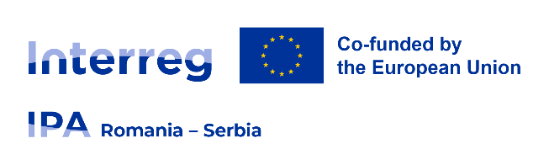

The logotype, EU emblem border and statement must be in white, while the EU flag keeps the Reflex Blue C colour or equivalent as it is described previously.

**According to EU regulations Common Provisions Regulation (CPR), Annex VIII the EU emblem always comes with a white border around the rectangle. The width of the border is 1/25 of the height of the rectangle.**

**Monochrome** version may only be used in justified cases.

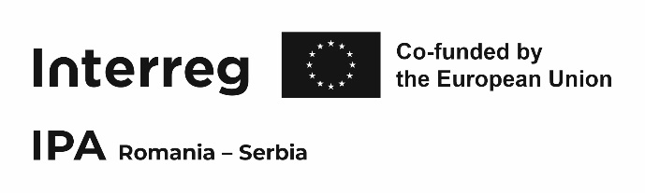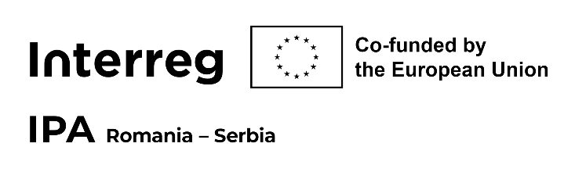For single colour reproductions or engravings, a monochrome version of the brand is available. This version should be used whenever colour versions are not available. The EU emblem must be applied in white with a black border measuring 1/25 of the height of the rectangle.

Black

Colour

CMYK: 0, 0, 0, 100

PANTONE BLACK

RGB: 0, 0, 0

Hexadecimal: 000000

CMYK: 0, 0, 0, 0

PANTONE /

RGB: 255, 255, 255

Hexadecimal: fffff

White

Colour

**Programme logo:**

**Always use the digital logo files provided;**

**Do not try to recreate or modify the logo in any way;**

**Colour version is recommended and shall be used whenever possible;**

**White & colour EU logo** is an alternative for dark/coloured backgrounds;

**The monochrome version may only be used in justified cases.**

# **Size of the Programme logo**

On communication materials, **the minimum length of the logo should allow a clear reading of the logo**. For example, when designing an A4 printed material, as an appropriate choice, the Interreg logo type + the EU flag should have a **minimum length of 38-40 mm.**

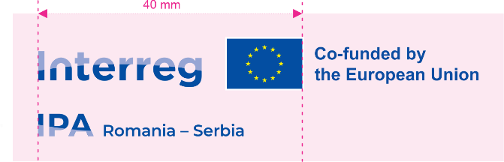

**If other logos are displayed in addition to the Programme logo and the European Union emblem it includes, the Union emblem shall have at least the same size, measured in height or width, as the biggest of the other logos.**

# **Language versions of the Programme logo**

The Interreg IPA Romania-Serbia Programme logo has four versions: Romanian, English, Serbian Cyrillic and Serbian Latin.

|  |  |
| --- | --- |
| **Language versions** |  |
| **English version** of the Programme logo |  |
| **Romanian version** of the Programme logo |  |
| **Serbian Cyrillic** version of the Programme logo |  |
| **Serbian Latin** version of the Programme logo |  |

The logo of the Interreg IPA Romania-Serbia Programme must be used on all communication and promotional materials funded by the Programme.

**Match the language of the logo to the language of your material as follows**:

* All materials issued for the Romanian public shall bear at least the Romanian version of the logo;
* All materials issued for the Serbian public shall bear at least the Serbian version of the logo (Cyrillic or Latin, in accordance with the alphabet used);
* All materials used to disseminate information to third parties targeted as English speakers, which is the common language of the Programme, shall bear the English version of the logo;
* When editing bilingual/trilingual communication materials, the official logo and disclaimers will be in English as this is the common language of the Programme. If the bilingual material uses only Romanian and Serbian languages, the official logo and disclaimers will be in one of these languages.

**All materials issued shall comply with the above provisions taking into account the main target group or the message for each material.**

**The projects should have bilingual communication tools addressing both sides of the border.** This means that the cross-border partners together should communicate on both sides of the border at least the project results outlining the European Union support and the Interreg IPA Romania-Serbia Programme contribution to the project.

# **Typography of the Interreg IPA Romania-Serbia Programme**

**Open Sans** is the **recommended font to be used** in all communication materials made during project implementation, especially for all print publications and stationery applications.

Open Sans has a neutral appearance suitable for all applications, being very versatile because of its broad variety of weights and styles. Open Sans was optimized for print, web, and mobile interfaces and has excellent legibility characteristics in its letterforms.

**As an alternative** to Open Sans, **you may choose Vollkorn Font Family** for overall communication. It can be used alone or in combination with Open Sans.

Within the Programme area, we are dealing with two types of the alphabet in official communication, the Latin alphabet with special characters as it is *ă, â, ć, đ, î, ș, š, č, ț* in Romania and the Cyrillic alphabet (example of letters *Ц, Ч, Ш*) as national script of the Republic of Serbia. Secondly, the designers use different devices and programmes from different companies in their creative work.

If Open Sans or Vollkorn typefaces are not suitable to be used, you may choose to replace Open Sans with Arial (sans-serif) and Vollkorn with Georgia (serif).

**Official fonts of the Interreg IPA Romania-Serbia Programme are the following fonts: Open Sans and Vollkorn**. **They are recommended to be used!**

**Recommended fonts to be used:**

**Open Sans** is the recommended font to be used;

**Vollkorn** is the secondary typeface to be used;

Open Sans **can be used alone or in combination** with Vollkorn.

The fonts are available here:

**Open Sans:**

<http://www.fontsquirrel.com/fonts/open-sans>

**Vollkorn:**

<http://www.fontsquirrel.com/fonts/vollkorn>

**Montserrat:** Interreg IPA Romania-Serbia Programme logo – Do not modify the logo!

<http://www.fontsquirrel.com/fonts/montserrat>

**Arial:**

<https://freefontsfamily.com/arial-font-family-free-download/>

**Georgia:**

<https://freefontsdownload.net/free-georgia-font-33927.htm>

*Vollkorn Italic*

Vollkorn

# **EU Cohesion Policy Objectives: Our Priority Icons**

The Interreg IPA Romania-Serbia Programme supports investments under three programme priorities linked with three EU policy objectives, each having its own icon: GREEN, SOCIAL and GOVERNANCE. Please do not modify these icons.

**The standard use of the icons is in colour.** These icons can be used either with a transparent or white background.

|  |  |  |  |
| --- | --- | --- | --- |
| **Standard icons** | Environmental protection and risk management | Social and economic development | Increasing border management capacity |
| Positive -  white background |  |  |  |
| Positive –  transparent background |  |  |  |
| Negative |  |  |  |

|  |  |  |
| --- | --- | --- |
| **Priority Colour Codes within the Interreg IPA Romania-Serbia Programme** | | |
|  | Environmental protection and risk management | CMYK: 48, 0, 89, 0  RGB: 154, 202, 60  Hexadecimal: #9ACA3C |
|  | Social and economic development | CMYK: 10, 75, 60, 1  RGB: 218, 92, 87  Hexadecimal: #DA5C57 |
|  | Increasing border management capacity | CMYK: 87, 51, 0, 0  RGB: 14, 110, 182  Hexadecimal: #0E6EB6 |

**The positive monochromatic version** shall be used whenever it is not possible or desired to use the colour versions. **The negative monochromatic version** of the icons should be used **as the last option** when other solutions are not possible or desired, such as printing purposes when placed on a dark or busy background.

|  |  |  |  |
| --- | --- | --- | --- |
|  | Environmental protection and risk management | Social and economic development | Increasing border management capacity |
| Positive monochromatic -  White background |  |  |  |
| Positive monochromatic -  Transparent background |  |  |  |
| Negative monochromatic |  |  |  |

**How to use the icons?**

The icons may be used in association with the suitable priority of the project.

The Programme authorities may use all three icons for promotional purposes.

# **Plain language**

Plain language is a form of communication that your audience can understand the first time they read or hear it.

|  |  |
| --- | --- |
| **Plain** = easy to see or understand | **Plain** |
| **Synonyms** | **Antonyms** |
| clear; obvious; understandable; transparent; evident; comprehensible, … | unclear; uncommon; ambiguous; vague; complicated; complex; incomprehensible. |

Language that is plain to one set of readers (for you, for me and for our colleagues) may not be plain to others (readers of a newspaper). A technical report used within the Programme may be plain for the persons who are dealing with it, but it may be too complicated, uncommon and complex for a journalist.

Use your project application form and technical reports as sources of information, not as the final text included in your communication material.

**Plain language should be used in all languages**: English, Romanian and Serbian. **Always adapt your language to your public!**

# **Public speaking**

Public speaking represents the personal ability to communicate orally in public with a group of people. Usually, there are different types of speeches depending on the results that you may want to obtain: informative, persuasive, and entertaining, but often it can be an overlap between them.

Before delivering a speech, prepare yourself and gather all the necessary information. Depending on the professional experience of the audience, choose the best balance between the technical and plain language used.

Dealing with journalists and giving interviews represents a type of public speaking. During mass media interviews, it is necessary to use the correct forms of the official names of the institutions involved in your project, including the name of the Programme.

**Within Interreg IPA Romania-Serbia Programme, we always ensure transparency of the data provided, keeping in mind the public interest.**

# **Presentations**

A presentation is a communication tool used to help a speaker to deliver a message to an audience. The presentation involves a mix of components, both technical and related to the personal skills of the speaker.

During your presentation, try to communicate effectively with your audience, involving them in the presentation, speaking clearly and slowly but with a dynamic tempo, and knowing your topic and material beyond the bullet points.

In your presentation, it is necessary to have a clear visual identity of the **Interreg IPA Romania-Serbia Programme logo**.

We provide a template design for your slides, but you should remember to keep your slides clear and clean. A ”5x5 general rule” says that there should be a maximum of 5 lines per slide and a maximum of 5 words per line.

**During your oral presentation, outline the European Union and Programme contribution to your project**.

Please have in mind this list when deliver a **presentation.**

* **include Programme visual identity;**
* Make sure the audience can read the slides!
* Use graphic and photos, but do not exaggerate!
* 1 slide = 1 idea;
* If there is too much text on the screen, your audience will lose interest;
* Check grammar!

# **Events**

The partners could organise events for promoting the projects results. These events could involve the physical presence of the participants or they could be organised as online and/or hybrid events, observing the legal provisions related to the safety of participants and organizers.

The projects are encouraged to organise public events involving a great number of participants, addressing all target groups mentioned in application form, but especially keeping in mind the general public.

These promotion events will be a good opportunity for the partners to promote the positive impact of the financed projects in the context of large European celebration events (such as Interreg Cooperation Day, Europe Day, Danube Day) or regional sports events, local fairs, thematic festivals.

The events (e.g. info days, caravans, trainings and thematic seminars etc.) should have an interactive format and represent an opportunity for a direct dialogue between participants and project representatives/speakers.

For operations of strategic importance and operations whose total cost exceeds **€5,000,000**, organising a **communication event** and involving the Commission and the responsible managing authority in a timely manner is **mandatory**.

Operations of strategic importance are emblematic projects which aim to tell the story of the Programme and bring more awareness about the importance of the positive effects of European Union support for the citizens living in the Programme area.

Communicating operations of strategic importance requires particular attention and should involve Programme authorities and beneficiaries altogether in order to reach higher visibility.

For increasing the awareness and visibility of these events, the live transmission could be available on the different social platforms and the offline video archive could be published on the programme webpage. Also, press conferences should be organised with local and regional mass media and national/EU officials, and relevant stakeholders may be invited as speakers.

The programme bodies will assure close coordination with beneficiaries of the strategic importance/large infrastructure projects in order to achieve optimum organization of mandatory visibility activities, while ensuring that the Commission is timely informed about the communication event or activity (2 or 3 months in advance).

Also, the programme bodies will actively support the strategic importance/large infrastructure projects in organising communication events, with logistical and promotion materials (videos, presentations, testimonials etc.) and publicity campaigns on programme website and social media networks.

Please have in mind this list when **organising the event:**

* All participants should be encouraged to fill in the list of participants.
* All participants should sign a written consent form for using personal data, images, audio and videomaterials **in accordance with the General Data Protection Regulation (GDPR) and specific national legislation.**
* When the participants are minors, written consent for using personal data, images, audio and video materials should be signed in by all parents **in accordance with the GDPR and national specific legislation.**
* The written consent is not required for outdoor events with a large number of participants.

Projects partners from operations of strategic importance could use the **practical toolbox** developed and provided by the European Commission where they have access to advice and concrete examples useful in preparing the information and publicity activities and could be consulted at the following link: <https://romania-serbia.net/wp-content/uploads/2024/02/communicating_operations_2021-2027_updated_EN.pdf>

# **Photographs**

**We strongly recommend** **developing a database of high-quality digital photographs** regarding **all stages of the project** so that they can be used to promote the project or the programme.

The Programme bodies of the Programme may ask project partners to put at their disposal relevant, large-sized photographs taken during the project’s implementation to include them in promotional materials developed at the Programme level.

For promotional and communication materials, **do not use photos and images downloaded from the Internet or other sources without having copyrights or having the legal term of being free to use.**

Please have in mind this list before publishing **photographs:**

* develop a database of high-quality photographs with project visibility included;
* you have the copy-right to use the photo or it belongs to you;
* it has a good quality (preferably best quality) in terms of technical standards;
* you need a higher quality of images for posters, roll-ups, brochures etc.
* you need a medium quality image for technical reports in word-processing software;
* *high-quality images*: use at least an entry level of DSLR/mirrorless photo camera;
* *medium quality images*: compact photo-cameras, phones with photo camera etc.

When people can be identified in the photographs, please have their written consent to use their image, in accordance with General Data Protection Regulation (GDPR) and national specific legislation.

**Press Releases**

A **press release** is a document sent to journalists on behalf of your institution to announce news or events associated with the project implemented under the Interreg IPA Romania-Serbia Programme. It can promote a range of news items, including scheduled events /conferences, results of your project, and basic facts needed by reporters to develop a news story.

Journalists like clear and concise press releases. Please provide them with all the information they need to know, in a journalistic manner, to attract their interest.

In your press release, answer the following questions:

* **Who?** Who is involved? Who does it benefit?
* **What?** What is new?
* **Why?** Why is this important news?
* **Where?** Where is this happening?
* **When?**
* **How?**

Before you issue a press release, ask yourself if your story has news value and plan the content of your press release with due attention to detail.

Remember to keep in contact with journalists! Human contact may be the key difference between a press release lost under an email spam filter and a piece of published news after a press release.

Please have in mind this list before making public a **press release:**

* **use the Programme visual identity template;**
* **outline the EU financial contribution;**
* keep the message clear;
* use the journalistic style of writing;
* don’t be afraid to be creative in order to attract readers in your text;
* don’t be abstract! use real examples and results of your project;
* use active voice instead of passive voice;
* write using every day (usual) words avoiding technical words (jargons);
* good quality images, if they are attached, connected with the message;
* Proofread!

# **Advertisements**

**Advertisements are paid messages**. Because you pay for it, you have control over the body of the message. You can choose the channel of distribution and may decide on how long to advertise.

As a general rule, you should adapt your message to the channel and try to reach your public, being clear, brief and creative using the best image(s) possible.

Create a story for your project (advertisement) and outline the European Union/ Programme contribution! If other logos are included (for example your institution`s logo), please keep in mind to use the same proportion size between the Interreg IPA Romania-Serbia Programme logo and other logos included.

If your press advertisement communicates information about a public procurement activity, you must respect the rules imposed by the public procurement procedure.

Please have in mind this list before making public a **press advertisement:**

* **use the Programme visual identity;**
* **outline EU involvement in the project combining the image with official logos;**
* because the message is paid, you have the control over it;
* be creative!
* keep the message clear!
* use best quality image;
* if it is a public procurement announcement **- respect the rules imposed by the public procurement procedure etc.**

# **Social Media**

Social media are interactive technologies that facilitate creating and sharing of information, ideas and interests through virtual communities. Social media can be viewed as an online facilitator that enhances social connectivity.

Compared with previous years, the role of social media in communication has increased considerably. Using social media platforms, we can reach very different audiences, defining more specific or larger groups of people, potential users of our projects, beneficiaries or citizens living in the Romanian-Serbian border area.

Because social media is so diverse, covering large segments of the public, at the Programme level, we focus on Facebook, Instagram, Twitter and YouTube. These social platforms are preferred by users in Romania and Serbia, covering large segments of people.

We encourage our projects to be active in promoting their projects on social media and share the posts made by the Programme through social media channels.

Like, Share and Subscribe to Interreg IPA Romania-Serbia Programme on Facebook, Instagram, Twitter and YouTube.

In recent years, due to Covid pandemic restrictions, we have started using different online platforms for technical meetings, especially Zoom and Microsoft Teams. Beyond the limits, these platforms proved to be very useful tools for communicating in an online environment and may be used in the future.

The Programme logo can be applied on the cover or banner picture – provided that the social media platform provides this option.

# **Social media hash tagging**

Using hashtags is a way to group together conversations or content around a certain topic, making it easy for people to find content that interests them. They always start with the **#** symbol, but they won’t work if you use spaces, punctuation, or other symbols.

At the Programme level, we are using the following hashtags: #Interreg #InterregIPA #RomaniaSerbia #EUfunded #CohesionPolicy #EUinmyRegion

Secondly, we are connecting our tags with different events or interests like: #CrossBorderCooperation #Cooperation #InterregDay #EuropeDay #MonitoringCommittee #PartnerSearchForum #Youth4Coop #EuropeanYearOfSkills etc.

For project partners, to create a link between all the posts related with your project, we recommend to use a hashtag composed by the acronym RORS, which stands from Romania and Serbia, and the Jems project number using the format e.g. #RORS00000.

**Helpful hint:** search Facebook for #RORS15 and see the results associated with this hashtag. RORS15 *is just an example to see how a hashtag works, being associated with a project funded under the previous Programme.*

For the moment, the hashtag format #RORS and the number is unique, but we do not have the exclusivity on it.

In order to increase the audience for your posts, you may want to add general hashtags like the name of the town/city where the project is implemented, general subjects of interests or domains: #Resita #Vrsac #Doctor #StopCancer #Danube #Environment #EarthDay This type of hashtag will increase your audience, but may be less relevant to some people. Either way it will boost your post to other audiences linked to that hashtag.

Last but not least, be aware of language specificity: #Danube #Dunav #Dunare represent the same river, but you can segment your audience by the language used. #Bega #Timisoara will be used to address Romanians and #Begej #Temišvar, to Serbians.

# **Social media tagging using @**

The “@” symbol is for tagging actual accounts within the social media platforms. If you type the “@” symbol immediately followed by a person’s or business’ profile name, that account will be notified of your post. This also makes the name clickable.

Let’s say you wanted to tag Interreg IPA Romania-Serbia Programme in your post on **facebook**. You would write: @ipacbcrose and it will link to the Programme **facebook** page.

For the Programme **Twitter** page, use @IPACBCRORS.

For the Programme **Instagram** page, use @ipacbcrors.

# **Websites**

Each partner shall provide on the **partner’s official website** or **social media sites**, **where such sites exist**, a **short description** of the **project**, including its **aims** and **results**, and highlighting the financial support from the Programme by using the **Programme logo**.

**The Programme logo (which includes the EU emblem) should be visible when landing on the already existing website, inside the viewing area of a digital device, without requiring a user to scroll down the page, if possible.**

**A link to the Programme website should be included.**

# **Audio materials**

*Audio materials* **(radio spots)** are useful to broadcast very fast information regarding different events (launching or closure events of the project, a seminar, etc.) or to raise the awareness of the project among the public. Radio spots may be flexible and easy to produce, but involve a high repeating rate of the message in order to reach the public.

When realizing radio advertisements, at the end of the spot the following message should be inserted:

”Interreg IPA Romania-Serbia Programme is co-funded by the European Union and the partner states in the Programme.”

The message must be in the language of the spot.

Please have in mind this list before broadcasting **an audio spot:**

* is creative and may attract people to listen it;
* use a clear language;
* best quality of sound;
* technical message is included etc.

# **Audio-visual materials/video spots/films**

A technical frame must be included at the end of the video spot. The frame will present the logo of the Programme and technical section.

The technical final frame of the film must be in the language of the spot.

Please have in mind this list before broadcasting a **video spot/film:**

* is creative and may attract people to watch it;
* use a clear language;
* best quality of image and sound;
* you outlined the EU/Programme financing in the project (visual and/or verbal);
* technical frame is included;
* be transparent!

# **Publications, brochures, leaflets etc.**

A brochure or a leaflet is an informative document handed out personally during an event or placed in brochure racks. They have different dimensions and a different number of pages, adaptable to the quantity of information and represent a form of direct marketing communication. They are also available in electronic formats.

Within the Programme, regardless of the number of pages, **a brochure or a leaflet must include the Programme logo, the name of your project, the disclaimer and technical section and the Programme website:** [**www.romania-serbia.net**](http://www.romania-serbia.net)

The publications edited within a project funded under the Programme shall include the **name of the project and logo of the Programme, on the first and the last cover**. The publications shall also contain contacts (persons, institution/organization, phone, fax, email and postal address) for the persons interested in finding out further details. The responsibility for the content of materials belongs solely to the Partner.

The logos of the contractor/subcontractor/consulting companies are not allowed, nor those containing slogans/advertising messages in favour of commercial companies. Brand elements of material/equipment manufacturers do not fall into this category.

In the case of projects that include studies/analyses etc., involving research work/scientific studies carried out under a service contract, the beneficiary has the option to include the name of the provider on the **inside page** of the respective document, with the mention "Prepared by...", accompanied by the logo, if any. If it is a work that involves a high degree of creativity and is the result of the work of more than one person, the mention may be "Prepared by...and written by..." or similar.

We strongly recommend outlining the European Union's financial contribution to the project in the text.

Regarding design, it is recommended to be creative and mix photos, graphics and text smoothly. Combine all the elements to attract readers to open your brochure/flyer.

Please do not overload your brochure with information because it is not a technical report or a newsletter addressed to specialists. If it is necessary to add more details, it is better to add an extra page instead of packing too much information in one page, which makes it harder to read.

Please have in mind this list before publishing a **brochure/flyer.**

* **use the Programme visual identity;**
* **outline EU financial contribution in the text;**
* **use the technical section;**
* **promote** www.romania-serbia.net website;
* do not overload it with information and be creative;
* use excellent quality images etc.

# **Information disclaimers**

Communication materials with content, for example videos, brochures and leaflets, developed within a project funded under Interreg IPA Romania-Serbia Programme should include the following:

* **Interreg IPA Romania-Serbia Programme logo (mandatory);**
* The icon selected in accordance with the priority which finances your project;
* **A technical section**, as described below, to identify the name of the project, Jems code, the material editor, the contact details, the publishing date, EU disclaimer, contact details of the Managing Authority, website of the Programme.

# **Technical section**

Project title and Jems code:

Material editor/Responsible for publication *(usually the project partner)*:

Contact details of *the project partner who ordered and paid for the material* i.e. *the material editor* (e-mail / phone / website of the material editor etc.)

Publishing date:

The responsibility for the content of this material is that of the author(s). The content of this material does not necessarily represent the official position of the European Union.

Reproduction is authorised provided the source is acknowledged and any changes are indicated.

In case of any complaints, contact: romania-serbia@mdlpa.gov.ro

www.romania-serbia.net

The technical section may be formatted and arranged creatively on the last page as long as the information is present.

# **Posters**

A poster is a visual communication tool designed to be attached to a wall or published in media. Typically, the posters include textual and graphic elements, although a poster may be either fully graphical or full text.

If you design a poster, you must keep in mind that you are creating a visual presentation of information, which is why the poster design must be eye-catching and informative.

You may use a poster for advertising an upcoming event, a new result, a project activity, or to ensure transparency of the financial support from the EU.

Please have in mind this list before publishing a **poster:**

* **use the Programme visual identity;**
* information to identify your project (for example: project name, Jems Code, budget etc.);
* creative style with eye-catching design;
* have in mind the principles for designing a poster;
* use best quality images and graphics.

# **Banners and roll-ups**

A banner is a visual communication tool designed to promote your project, as well as the Programme. Due to the wide range of layouts, custom options and sizes offered, these tools are great for implementation both inside and outside.

The typology of banners includes: retractable banners, roll up banners, hanging banners, street banners, teardrop banners, promotional flags etc.

Inside banners may be used in your office to promote the programme/project to your visitors or to stand out during events. Outside banners are a method to promote your project to the local community/public.

***Keep your core message to the top:*** Use the top of your banner to display the Programme logo and your core message. It is important to have your main message at eye level.

When designing your banner, it is important to include relevant information and keep words to a minimum. More information can be provided in your brochures, flyers and reports. If you include any *images* on your banner, then be sure that they are high quality. All images and text must be clear and easy to read.

Please have in mind this list before publishing a **banner:**

* **use the Programme visual identity;**
* information to identify your project (for example: project name, Jems Code, budget etc.);
* creative style with eye-catching design;
* use best quality images;

**An Internet banner** is a form of online advertising on the World Wide Web (www). Web banners notify the readers of a web page about the EU financial support to your project received through the Programme or promote your project.

An internet banner may be dynamic or static and may have different formats. You may choose what type suits your project communication plan, but ensure that the official Programme logo is visible and it is linked to a web page/social media page which includes more information.

# **Durable plaques or billboards (mandatory version)**

The durable plaques or billboards shall be used to inform the public regarding the support received from the European Union, the Government of Romania and the Serbian Government.

For projects exceeding a total cost of **EUR 100,000**, **each partner** shall acknowledge the support from the EU by displaying **durable plaques or billboards** **clearly visible to the public**, presenting the logo of the Interreg IPA Romania-Serbia Programme, as soon as the physical implementation of the project involving physical investment or the purchase of equipment starts or purchased equipment is installed, as stated in EU Reg. 1059/2021 art. 36, paragraph 4(c).

Durable plaques or mandatory billboards should include: the logo of the Programme, name of the project with Jems Code, total budget, EU funding, duration of project.

**Billboards or durable plaques must be tailored according to the scale of the operations.** They must be comprehensive so that the target audience reads and understands the nature and funding resources of the project.

The beneficiary must choose which size of the durable plaque or billboard best fits the project site. Please send the template request to dani.bardos@brct-timisoara.ro **AND** to your Joint Secretariat Project Manager (name will be communicated by the Joint Secretariat).

**The templates are based on three colours**: blue, black and grey. Blue is the colour used in the lines, which accentuate the picture used and the content of the template in general. The project specific information, with the exception of the title is written in black. Finally, grey is used when no picture is added in the template. However, it should be noted that **adding a picture to the template is strongly recommended**.

|  |  |
| --- | --- |
|  | CMYK: 76, 43 0, 0  RGB: 63, 129, 195  Hexadecimal: #3f81c3 |
|  | CMYK: 0, 0, 0, 100  RGB: 0, 0, 0  Hexadecimal: #000000 |
|  | CMYK: 10, 8, 8, 0  RGB: 225, 225, 225  Hexadecimal: #e1e1e1 |

If placed on the Romanian side of the border, the billboard or durable plaque must be in the Romanian language. If placed on the Serbian side of the border, the billboard must be in the Serbian language.

Durable plaques/billboards shall be made of resistant materials so that their presence can be positively noted at any time.

Where it is not possible to place a durable plaque on a physical object (for example: because of restrictions imposed by legislation on protected buildings) other appropriate measures shall be taken in order to publicise the contribution of the Interreg IPA Romania-Serbia Programme (e.g. the durable plaque will be placed inside the entrance area of the building).

**Where several operations are taking place at the same location, supported by the same or different funding instruments, or where further funding is provided for the same operation at a later date, at least one plaque or billboard shall be displayed.**

# **Other touristic/outdoor signboards**

An outdoor signboard is a way of communication using signboards along roads or in public places where people gather or wait, like bus stops etc. If you plan to promote and raise awareness of your project in your local community, you may design a promotional or informational signboard.

**Also, you may use a sign to let travellers know about some cross-border touristic routes or a local historical attraction valued better because of your project.**

Before designing an outdoor signboard, please consider the length of time readers spend in front of your signboard. A roadside signboard must send the message in a few seconds, while a signboard placed in public places where people gather or wait may be studied longer by the readers.

Roadside signboards need to be simple, with clear images and as few words as possible. A simple message and a clear visual identity are always essential. Your sign should be easily visible from a distance and your message memorable.

If you position your signboard where people have more time to read, you may include more words, but do not exaggerate! This place may be the location of your project (ex: you cleaned an area to protect the cross-border environment, rehabilitated an important historical site etc.) or in a square, park or near a bus stop.

Outdoor communication using signboards may be beneficial in promoting your EU project and the Interreg IPA Romania-Serbia Programme.

Please have in mind this list when designing a **signboard:**

* **include the Programme visual identity;**
* be concise: Can you tell your story in 8-10 words?
* use best picture with high quality;
* be creative.

# **Newsletters**

A newsletter is a publication generally about one main topic of interest and distributed to subscribers and stakeholders. The newsletters may also be published on the web page describing your project.

Since this type of publication spreads information to persons who generally work in our field of activity, the newsletters may contain more technical language than brochures and flyers.

There are no minimum or a maximum number of pages, but when you design a newsletter, remember that the best communication is always clear. A newsletter is not a technical report, even if the newsletters go to subscribers and stakeholders and contain technical data.

From a technical point of view, you will include the Interreg IPA Romania-Serbia Programme logo on the first and last page. Also, the last page of the newsletter must contain the disclaimers and **technical section**, as described on page 29.

Please have in mind this list before publishing a **newsletter:**

* **include the Programme visual identity;**
* include technical section in order for people to find out more, if interested;
* create a design, include pictures, text, tables and graphic;
* have in mind the distribution method: electronically (RGB colour design) or printed (CMYK colour design).

# **Vehicle panels**

Any vehicles funded through Interreg IPA Romania-Serbia Programme should be clearly identified by using the Programme logo in the operational language of the Programme (English) and in the local language (Romanian or Serbian).

The project partner logo may appear on vehicles, although the EU flag should be displayed at least as prominently as the logos of all parties involved in the action.

The **minimum recommended size** of the panel for **all vehicles** (cars, trucks, special utility vehicles, vans etc.) is **A4.** If the design of the vehicle does not permit it, please consult the MA/JS for an alternative solution.

The **English** version of the panel will be posted on the **left side** of the vehicle.

The **local language** version of the panel (Romanian or Serbian) will be on the **right side** of the vehicle.

The model is available for download on the Programme website.

# **Self-Adhesives/Stickers/Tags**

Equipment, furniture and other purchased items through the Programme **must** bear a self-adhesive or a tag, depending on the material, in a visible place.

The self-adhesive/tag is a practical and versatile element to enhance the visibility of projects. The size may vary, depending on the object.

The self-adhesive/tag format design is available for download on the Programme website.

There are cases when the recommended self-adhesive/tag may not fit a small-dimension equipment. As an exception, the project partners may use a self-adhesive/tag containing only the European Union logo with text (Co-funded by the European Union).

# **Promotional items**

According to the Annex F - List of Eligible Expenditures for Interreg IPA Romania-Serbia Programme, article 4 letter b) **gifts are not eligible costs**.

Nevertheless, Annex F includes **promotional items** as eligible expenditure in *Article 10 External expertise and services costs*:

“*(1) Expenditure on external expertise and service costs shall be limited to the following services and expertise provided by a public or private law body or a natural person other than the beneficiary and all partners of the operation:*

*e) Promotion, communication, publicity,* ***promotional items*** *and activities or information (including publications) linked to an operation or to the Interreg IPA Romania – Serbia Programme as such;”*

There is a large variety of promotional items. Within this manual, it is not practical to cover all possible situations. Therefore, use the logo of the Interreg IPA Romania-Serbia Programme as a minimum visibility requirement on all your promotional items.

**If other logos are displayed in addition to the EU emblem contained in the Programme logo, the EU emblem must be at least the same size as the biggest of the other logos.**

Please have in mind this list when personalizing a promotional item:

* **use the Programme logo following the rules of using the EU flag;**
* avoid embossing, bi-colour printing and graphic treatments altering the symbols and the fonts expressly recommended by the VIM;
* for textile promotional objects (T-shirts, caps), aim for a large printable area and choose the printing method carefully while considering the design features.

# **Tender announcements for public procurements**

The tender announcements made available on websites and/or communicated to mass-media, will include all the necessary information required according to the applicable law and Programme regulations. When possible, include the Programme logo in tender announcements.

# **Attendance certificates and diplomas**

Any document, including any attendance or other certificates, which is used for the public or for participants, shall include the Interreg IPA Romania-Serbia Programme logo.

# **Green communication tips**

**In case of any doubt in using the logos/compulsory information or special layout requests, please consult the Joint Secretariat experts!**

* Joint Secretariat experts are ready to offer support to project promoters regarding communication activities.
* Your e-mails must be sent to dani.bardos@brct-timisoara.ro **AND** to your Joint Secretariat Project Manager (name will be previously communicated by the Joint Secretariat).

**We aim to answer your questions in maximum 3 working days, but usually faster.**

Having regard to the measures for reducing the negative impact of the health and energy crisis and the self-commitment to reducing the carbon footprint of the Programme taken by the bodies involved in the implementation of the Programme (Managing Authority, National Authority, Joint Secretariat, Joint Secretariat Antenna) and project beneficiaries, the following principles are recommended, when possible, for all communication activities and materials:

* **Online communication** – reducing physical events with a large number of participants and switching to more online or hybrid events (online format and small number of participants in physical format); electronic communication should be used instead of printed materials for pre-meeting and follow-up communications; the use of decorative elements should be minimised; reuse of badges and banners is encouraged;
* **Paperless** and **digitalisation** – storing documents in digital archives and encouraging the deletion of "non-essential" emails (a large number of emails on servers leads to high energy consumption), using the electronic signature; publications disseminated by electronic means; recycled paper, print on both sides, print-friendly;
* **Go local!** – promoting local products/small food local businesses;
* **0% plastic waste** and drastic reduction of promotional materials on hard copy; all materials: brochures, guidelines for applicants, training materials and Q&A will be posted in digital format on the Programme website. Project promotion templates will be available for beneficiaries on the Programme website and could be tailored for different events. Developing the promotional items that are needed, relevant and have a high use value;
* The **use of natural light**is preferred;
* The **use of energy-efficient light bulbs** is strongly encouraged.

# **Incorrect use of the brand**

* The logo of the Interreg IPA CBC Romania-Serbia Programme used during 2014-2020 should not be used anymore in conjunction with the present Programme.
* Do not use any other typographic element in addition to the Programme logo.
* Do not invert, distort, stretch, slant or modify the logo in any way.
* Do not cut the logo.
* Do not rotate the logo. The only correct use of the brand is horizontal at a 0º angle.
* Do not change the composition of the brand elements. They are invariable.
* Do not use outlines around the brand logo.
* Do not use the brand in body text. Instead, in body text use just the word Interreg set in the font of the body text.
* Do not use the brand in any other colour than the standard full-colour version or the accepted white and monochrome variations.
* Avoid coloured backgrounds as much as possible. White backgrounds should be preferred at any time.



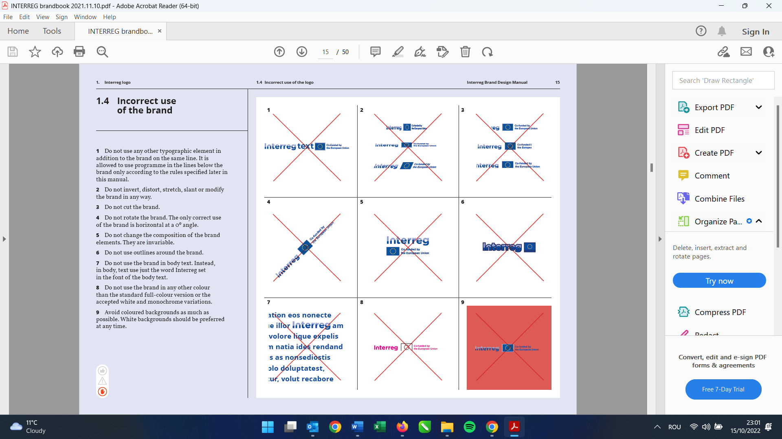



Project title: Technical Assistance for the implementation of the Interreg IPA Romania-Serbia Programme

Responsible for publication: Regional Office for Cross-border Cooperation Timisoara

Contact details: (+40)356426360; dani.bardos@brct-timisoara.ro

Publishing date: February 2025

The responsibility for the content of this material is that of the author(s). The content of this material does not necessarily represent the official position of the European Union.

Reproduction is authorised provided the source is acknowledged and any changes are indicated.

In case of any complaints, contact: romania-serbia@mdlpa.gov.ro

www.romania-serbia.net