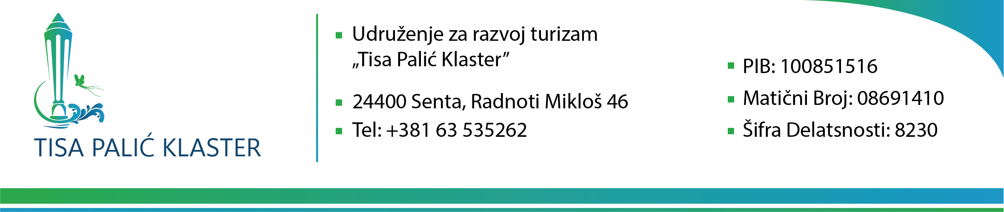

**AWARD DECISION**

PUBLICATION REF: RORS/00173/P1/3  
  
Development and implementation marketing strategy, participation in fairs and translation service

Maximum budget: EUR 46.000 = 5.393.040 RSD

The contracting authority, having examined the evaluation report prepared by the evaluation committee on the 21.07.2025, acknowledges that the evaluation committee recommends that ASOCIJACIJA ZA RAZVOJ OPŠTINE BAČKA TOPOLA is awarded the contract with a contract value of RSD 5.365.000

The contracting authority approves the evaluation report.

Following the evaluation committee's recommendation, the contracting authority takes the decision to award the contract to ASOCIJACIJA ZA RAZVOJ OPŠTINE BAČKA TOPOLA , the latter being the tenderer who provides the most economically advantageous tender while meeting the selection criteria.

**Name and signature: Veres Attila**

**Date: 22.07.2025**

Enclosure: Evaluation report