Project information
CALL FOR PROPOSALS | 2
e-MS Code: | RORS-218
PRIORITY AXIS: | 2 - Environmental protection and risk management
OBJECTIVE: | 2.2 - Environmental risks management and emergency preparedness
PROJECT TITLE: | Romanian – Serbian Cross-Border Risk Monitoring in case of Emergency Situations
ACRONYM: | CBRM
DURATION: | 15.04.2022 – 14.12.2023 (20 months)
Interreg-IPA  FUNDS CONTRACTED: | €1.053.068,23
TOTAL FUNDS CONTRACTED: | €1.238.903,82
ABSORPTION RATE (%): | 97 %
PROJECT OBJECTIVE(S): | Improving cross-border inter-operation, mitigation and prevention of environmental accidents, disasters and emergency reactions by specific equipment endowment of the professional and volunteer intervention structures and by joint sustainable actions.  Improving cross–border knowledge with regard to cross-border emergency situations management.
SHORT DESCRIPTION OF THE PROJECT: | This project is built starting from the three major risks of emergency situations (floods, fires, earthquakes) in the western area of Timis County and its Serbian neighbours from the Autonomous Province of Vojvodina - Central & Northern Banat Districts. It is oriented towards identifying and solving common problems - equipment, theoretical and practical professional training, monitoring, intervention mechanisms, and informing and educating citizens.  The project’s actions capitalize upon the cross–border cooperation framework to jointly plan and implement monitoring, prevention, intervention, and risk-decrease measures. The geography of the envisaged area and its associated risks determine the need for joint cross-border emergency situations risk monitoring and management.
DEGREE OF ACHIEVEMENT OF INDICATORS: | 33 - Joint intervention equipment.100 %  442 participants to project initiatives and events for information and awareness rising - Joint educational study visits and youth camp.102 %  1 – Cross-border study concerning SMART FLOOD MONITORING SYSTEMS in the project envisaged territorial area.100 %  3.481 participants to capacity building initiatives. 134 %  1 – Emergency situations monitoring and information and project promotion dedicated web  Platform. 100 %  926.522 – the population benefiting from flood protection measures.172 %
RESULTS ACHIEVED: | Minimum 3 sets of Joint Intervention Procedures and 1 Cooperation Agreement on Cross-border emergency situations management; 100 %  Cross-border IT Risk monitoring and project promotion platform; 100% https://rors218platform.eu/  Cross-border study concerning Smart Flood Monitoring Systems in the project envisaged area; 100 %  Joint training actions package execution (4 cross-border training sessions); 100%  Joint educational actions execution (2 cross-border study visits and 1 dedicated youth camp); 100 %  Joint tactical applications & exercises actions package execution (4 cross-border tactical applications); 100%  Joint specific intervention equipment procurement (33 items);100%  Joint meetings and conferences. 100%

Partnership information
 |  | COUNTRY | COUNTY/DISTRICT | BUDGET(EURO) | CONTACT DETAILS
LEAD PARTNER: | Inter-Community Development Association for the Management of Emergency Situations | Romania | Timis | 141.127,77 | Blv. Revoluției din 1989 19, 2nd floor, flat 7, Timisoara www.adivest.ro officeadivest@gmail.com  Telephone 0040 727379678
PARTNER 2: | Emergency Situation Inspectorate "Banat" of Timis County | Romania | Timis | 624.750,00 | Infrățirii Str. 13, Timisoara  www.isutimis.ro  Tel.: 0040 0256 434870
PARTNER 3: | Timis County Gendarmerie Inspectorate | Romania | Timis | 80.562,30 | Gheorghe Baritiu Street 19-21, Timisoara  www.jandarmeriatimis.ro  Tel.: 0040 749137634
PARTNER 4: | City of Zrenjanin | Serbia | Central Banat | 211.102,50 | Trg Slobode 10, Zrenjanin  www.zrenjanin.rs  Tel. : +38164 8116379
PARTNER 5: | City of Kikinda | Serbia | North Banat | 181.361,25 | Trg Srpskih Dobrovoljaca 12, Kikinda  www.kikinda.org.rs  Tel.: +381 (0)64/896-8179

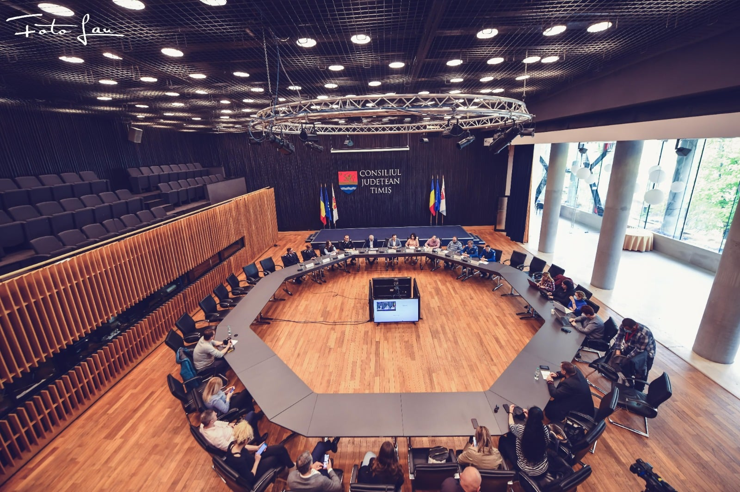
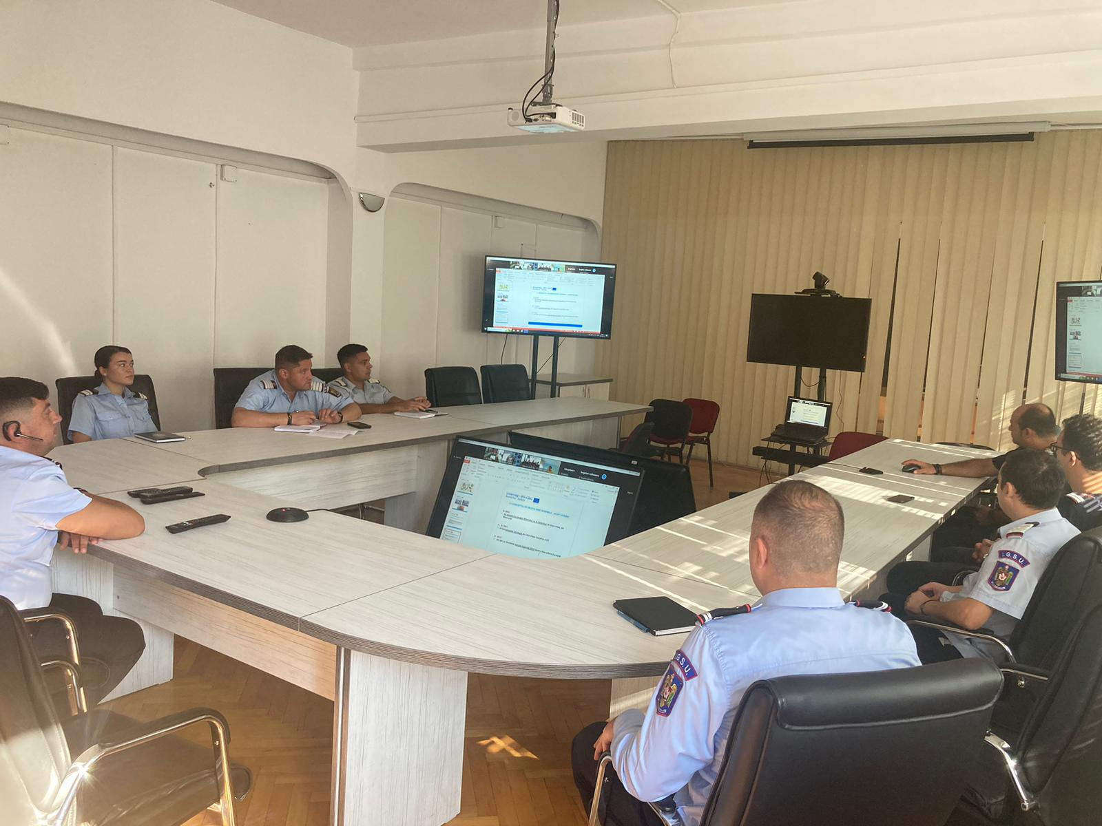

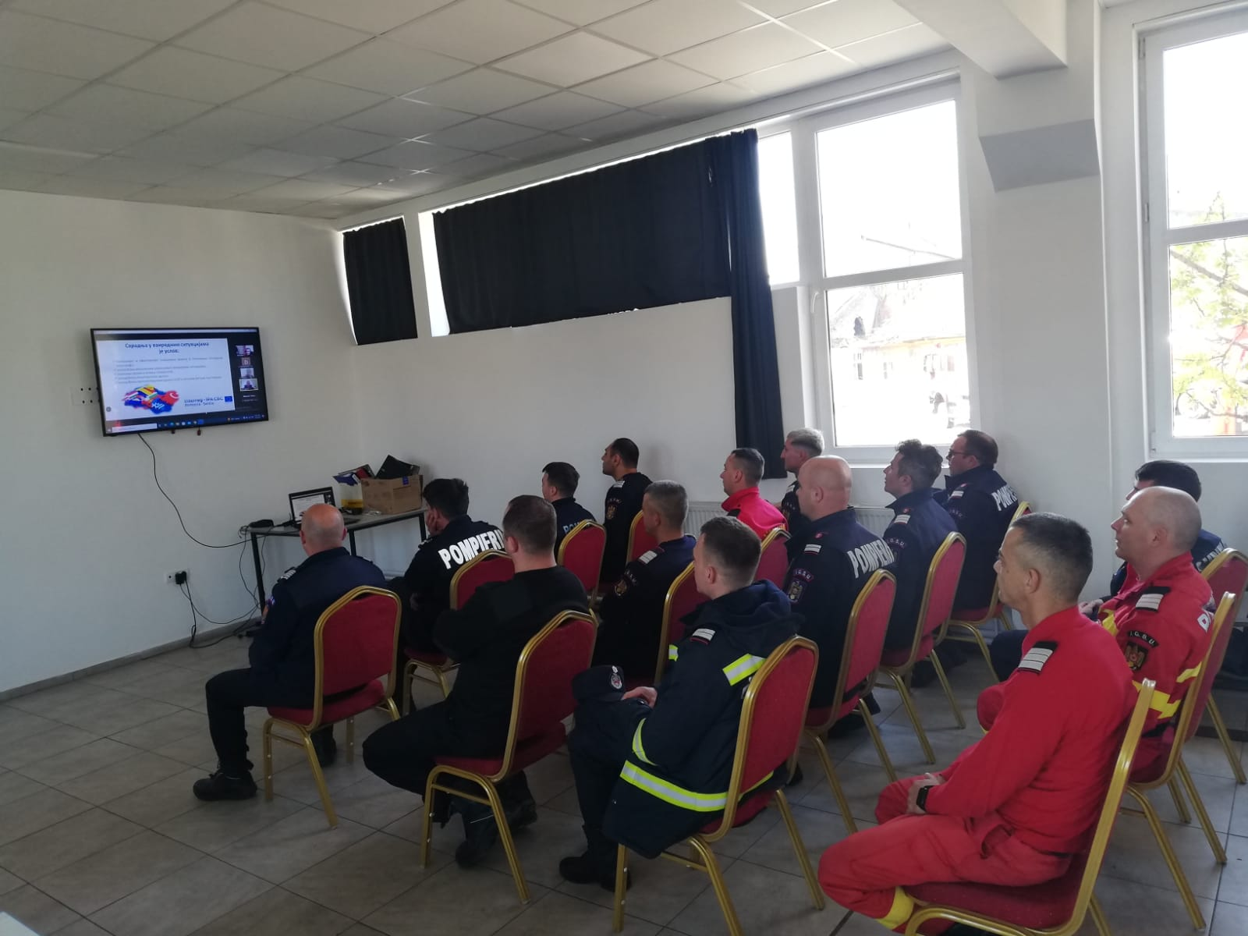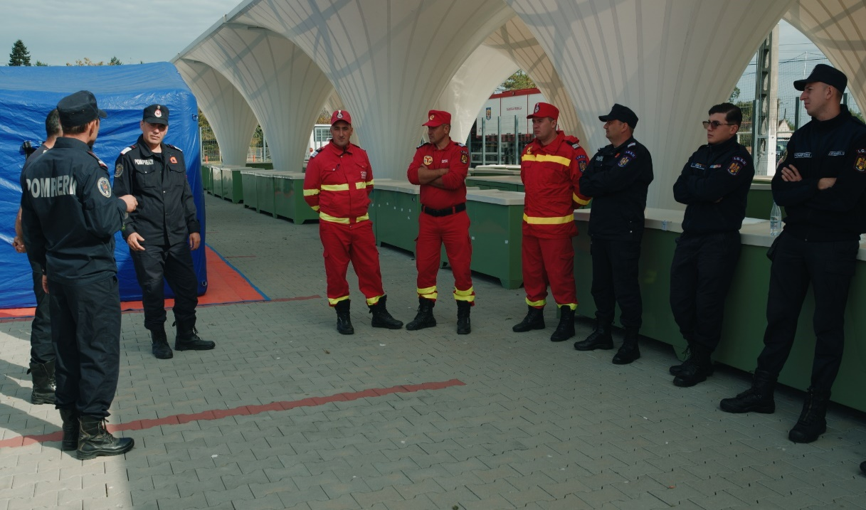

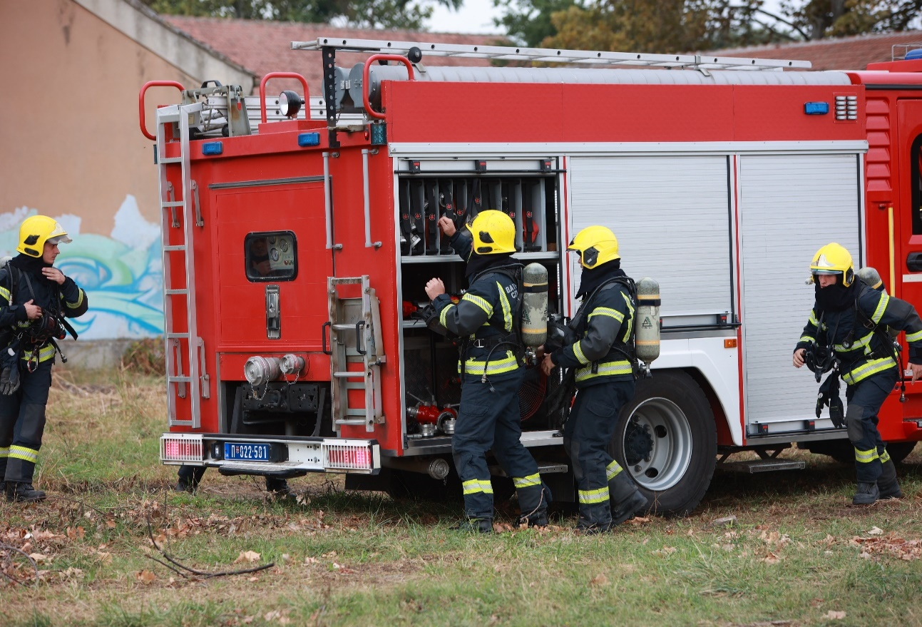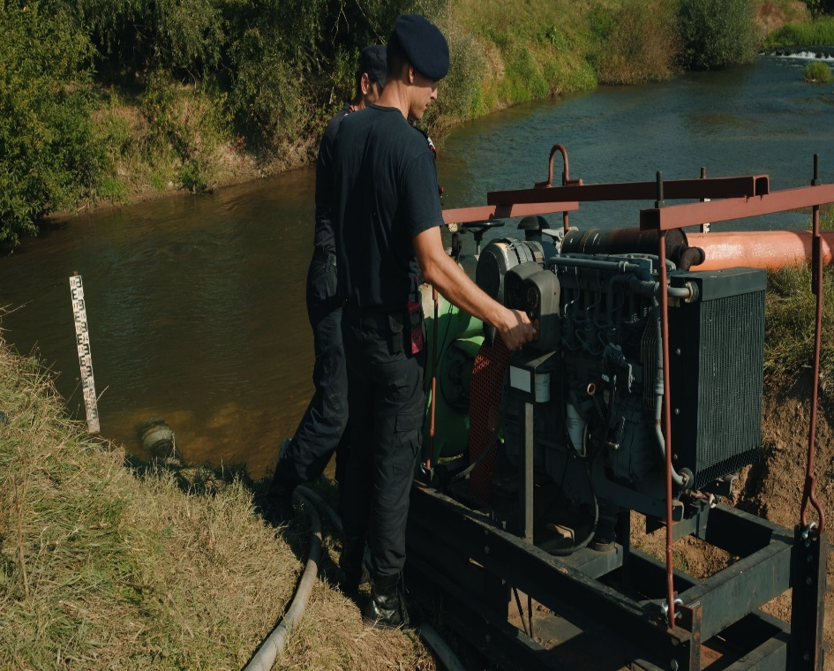

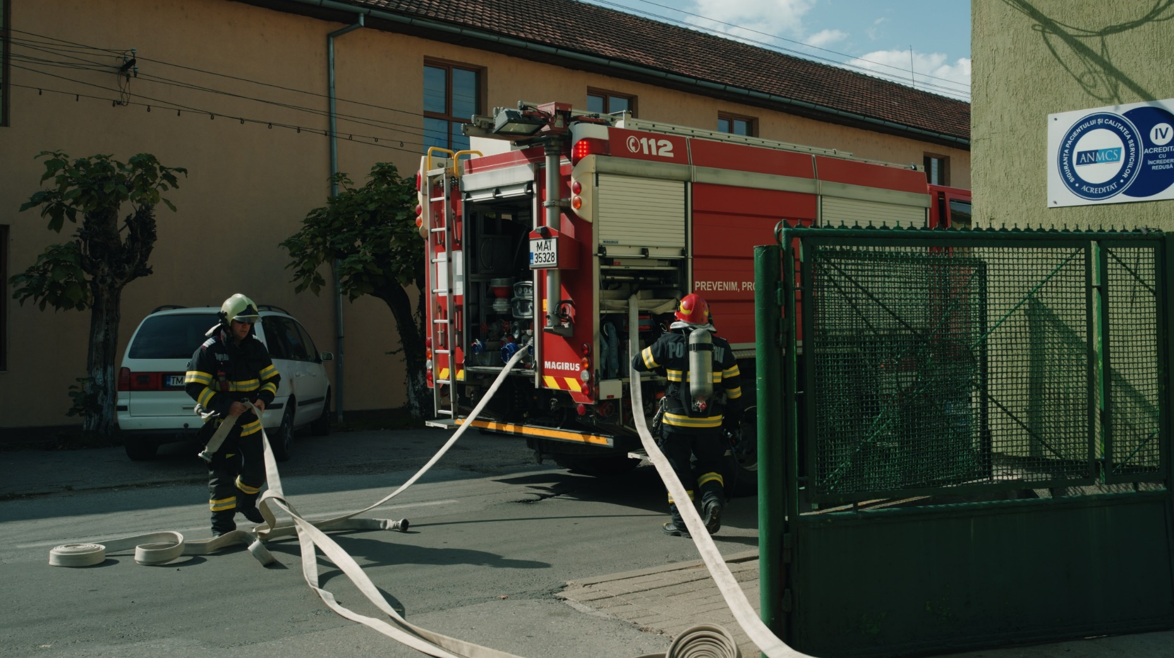

the implementation period (including extensions)
total funds spent/total funds contracted *100

