Project information
CALL FOR PROPOSALS | 2
e-MS Code: | RORS-425
PRIORITY AXIS: | 3 Sustainable mobility and accessibility
OBJECTIVE: | 3.2 Public utilities infrastructure
PROJECT TITLE: | Rehabilitation and Modernization of the Public Lighting System Lenauheim - Zagubica
ACRONYM: | RMPLS
DURATION: | 15.04.2022 – 14.12.2023 (20 months)
Interreg-IPA  FUNDS CONTRACTED: | €841.141,30
TOTAL FUNDS CONTRACTED: | €989.578,00
ABSORPTION RATE (%): | 98,84%
PROJECT OBJECTIVE(S): | The project aimed to increase the degree of comfort and the quality of life of citizens, reduce energy consumption, CO₂ emissions, and public lighting costs by modernizing, improving, and expanding public lighting from Lenauheim Commune in Romania and Municipality of Zagubica in Serbia.
SHORT DESCRIPTION OF THE PROJECT: | Lenauheim and Žagubica were switched to LED street lighting! The local authorities modernized and rehabilitated the public lighting systems, increasing the safety of the citizens and improving the orientation of road traffic.  The beneficiaries procured equipment that substantially reduces maintenance expenses and energetically efficient, energy-efficient pillars. They also implemented a telematics system that efficiently manages and monitors the entire lighting infrastructure. A study identified the possibilities, means, equipment and technologies that meets the municipality's objectives regarding the extension and modernization of the public lighting system.  Completing the public lighting system will considerably reduce energy consumption and costs, increase the efficiency of the luminous flux, and increase the safety of citizens and traffic.
DEGREE OF ACHIEVEMENT OF INDICATORS: | 2 investments realized in transport and utilities infrastructure, including improvement, enhancement of existing infrastructure. (100%)  366 participants attended information/training/awareness raising initiatives in the field of transport and public utilities. (122%)
RESULTS ACHIEVED: | 2 new lighting systems implemented. (100%)  106 people were informed about renewable energy and energy consumption. (106%)  260 citizens took part in raising awareness campaigns. (130%)

Partnership information
 |  | COUNTRY | COUNTY/DISTRICT | BUDGET(EURO) | CONTACT DETAILS
LEAD PARTNER: | Lenauheim Commune | Romania | Timis | 527.074,00 | 258 Lenauheim, 307240, lenauheim@upcmail.ro
PARTNER 2: | Municipality of Zagubica | Serbia | Branicevski | 462.504,00 | 1 Trg Oslobodenja, 12320, Zagubica  zagubica@opstinazagubica.rs

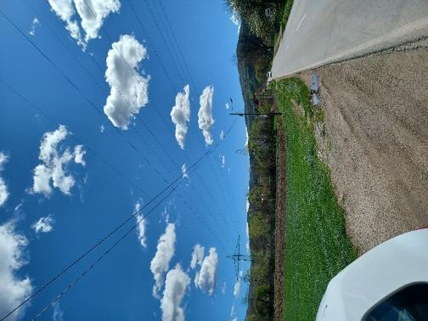
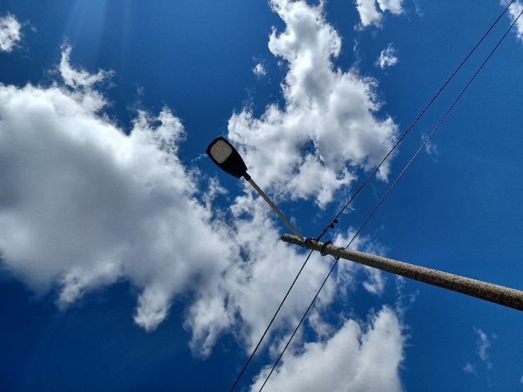
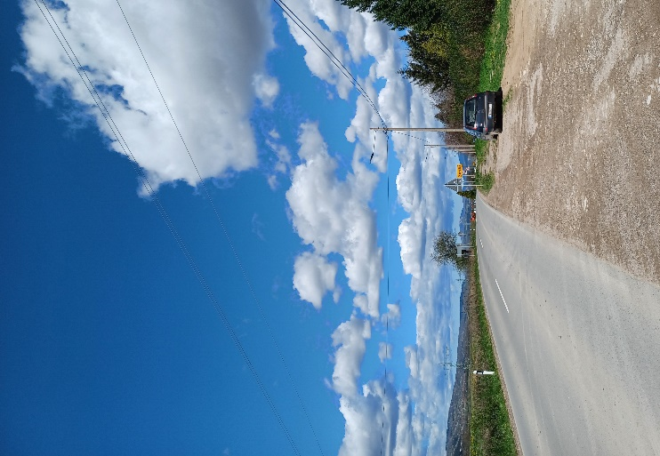

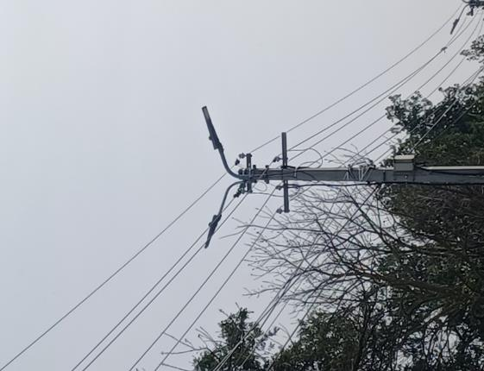
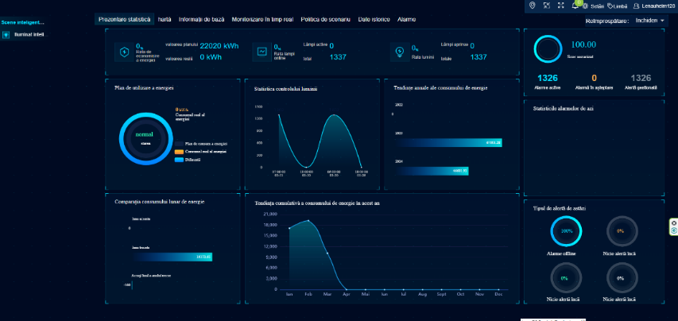
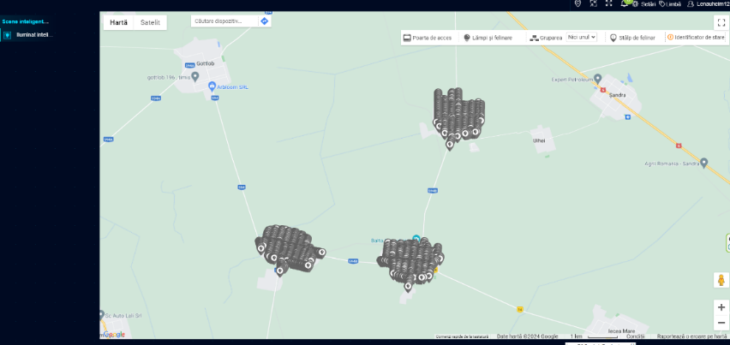
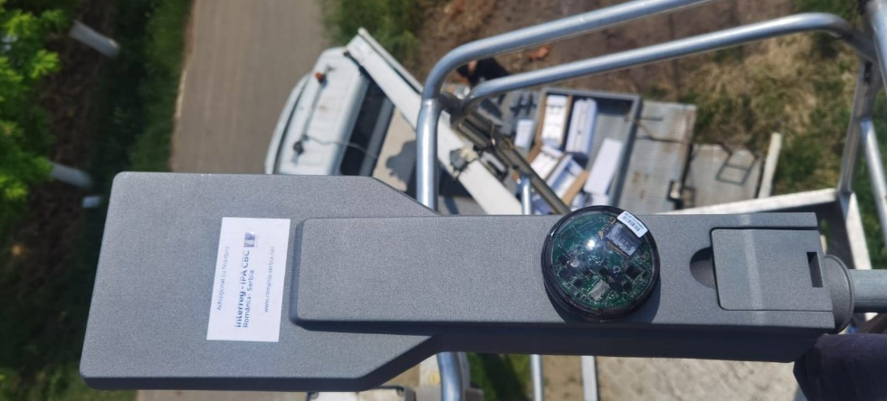
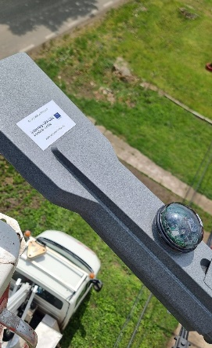
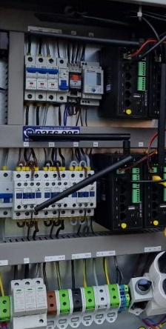

the implementation period (including extensions)
total funds spent/total funds contracted *100

