Project information
CALL FOR PROPOSALS | 1
MIS-ETC: | 514
PRIORITY AXIS: | 3 - Promoting “People to People” Exchanges
MEASURE: | 3.2 Improve local governance in relation to the provision of local services to communities in the border areas
PROJECT TITLE: | CULTURAL CENTERS – Poles of Excellence in Promoting Cross Border Living Heritage
ACRONYM: | CULTPOLS
DURATION: | 18.12.2010 – 17.04.2012
IPA FUNDS CONTRACTED: | 181.463,44 €
TOTAL FUNDS CONTRACTED: | 213.486,40 €
ABSORBTION RATE (%): | 58,04 %
PROJECT OBJECTIVE(S): | Increased efficiency and the quality of public services rendered by cultural houses leading to lively and empowered cross border rural communities by promoting local heritage, as a key source for culture, tourism development and cultural entrepreneurship.  Another objective is to strengthen the institutional capacity of rural cultural houses through adequate training adapted on their specific and current needs.  To promote the cultural houses as lively places in rural areas, able to reflect the community's identity, resources and roots.  To create a durable cross-border network of active cultural houses.  To strengthen the support environment and to identify areas of further cross border cooperation.
SHORT DESCRIPTION OF THE PROJECT: | The need for a vibrant cultural house is linked directly with the constrains faced by rural communities: poverty, depopulation, “old inherited” mentality, poor knowledge and lack of awareness on the development potential of communities, lack of professionalism of local authorities, lack of transparency and insufficient dialogue and capacity in community development process and in local integrated development planning.  The project led to the development of the local communities through raising the capacity of the cultural public services to play a key role in community development. The training provided during the project implementation empowered cultural house managers to become cultural mediators for both their community and for the community in the neighbour country.  By promoting their own values and traditions, people from the both communities learned to support their community and develop entrepreneurship skills for valorising the living heritage through rural and agritourism, thus, contributing to open a new development direction for the communities and a new job market.  At the end of the project 25 communities were linked through 4 exchange visits and 2 large dissemination events. The 2 Cultural Cross-border Resource and Training Centres created through the project maintained the network cooperation, expending it continuously and offering ongoing support for the cultural managers regarding information, knowledge and skills development.
DEGREE OF ACHIEVEMENT OF INDICATORS: | Indicator value provisioned in the contract Present indicator value % 6= (5)/(3)*100  Output indicators (1) UM (2) Quantity (3) UM (4) Quantity (5)  Stronger civil society of the border area Number 1 Number 1 100%  Increased integration of the border communities and improved local services in the border area Number 1 Number 1 100%  Result indicators  Increased integration of the border communities and improved local services in the border area Number of activities, actions, initiatives between local and regional public authorities in tackling joint problems, local service provision etc 13 Number of activities, actions, initiatives between local and regional public authorities in tackling joint problems, local service provision etc 14 108%  Improved knowledge of culture, history, society, organisational and institutional structure, and language of the neighbouring country Number of participants gained knew knowledge in events promoting/profiling the neighbouring country 155 Number of participants gained knew knowledge in events promoting/profiling the neighbouring country 155 100%  Project indicators  Strengthen the institutional capacity of rural cultural houses Number of cultural houses participating in the project activities 25 Number of cultural houses participating in the project activities 28 112%  Number of strategies/projects 10 Number of strategies/projects 11 110%  Number of cross border resource and training cultural centres established and equipped 2 Number of cross border resource and training cultural centres established and equipped 2 100%  Provision of training Number of organised trainings 8 Number of organised trainings 8 100  Number of participants taking part training course 25 Number of participants taking part training course 28 112%  Practical guide on development of cross-border cultural strategies / projects for valorisation for living heritage Nr of copies 250 Nr of copies 250 100%  Strengthen the cross-border cooperation among the cultural houses Nr of exchange visits 4 Nr of exchange visits 4 100%  Creation of the cross-border network of cultural house managers Nr of members 25 Nr of members 28 112%
RESULTS ACHIEVED, INCLUDING PHOTOS: | Improved knowledge, skills and competences regarding valorisation of living heritage, management and entrepreneurship, development of strategies and projects of cultural houses’ managers in rural areas of Romania and Serbia.  Raised visibility of cultural services and involvement of communities’ members in the cultural life and development of their communities.  Increased cross border cooperation leading to valorise the living heritage through coherent cross border strategies, partnerships and networking.  Setting up two Cultural Cross-border Resource and Training centres offered cross-border support for long-term cultural cooperation for the cultural centres in rural areas.
Project website: | http://cultpoles.rural-center.org

Partnership information
 |  | COUNTRY | COUNTY/DISTRICT | BUDGET(EURO) | CONTACT DETAILS
LEAD PARTNER: | Cultural Association “Constantin Brâncuşi” TIMIŞOARA” | Romania | Timis | 120.617 | Timisoara, 12 Macilor Str.  Tel. 004-0256403285
PARTNER 2: | Centre for Rural Assistance | Romania | Timis | 73.220 | Timisoara, 6 Istria Square,  Tel. 004-0256221470
PARTNER 3: | House of Culture " 3 October" | Serbia | South Banat | 19.649,4 | BANATSKO NOVO SELO,  M. TITA 73  Tel. 0038-113615114
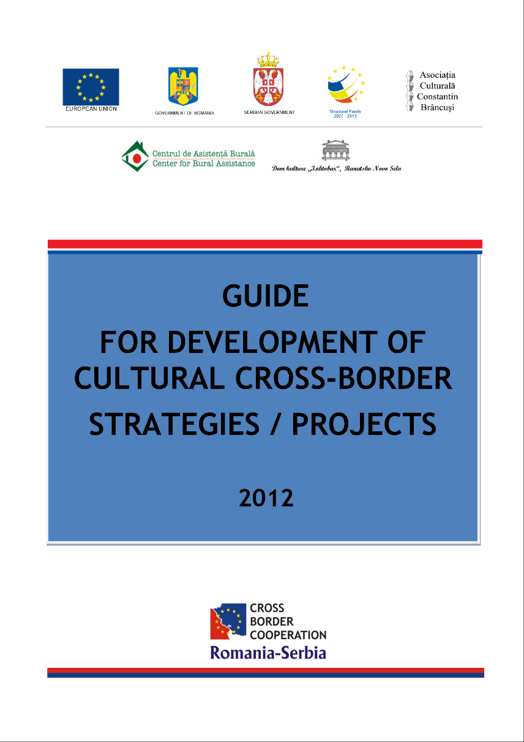
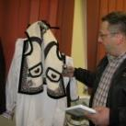
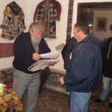
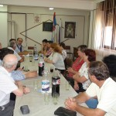
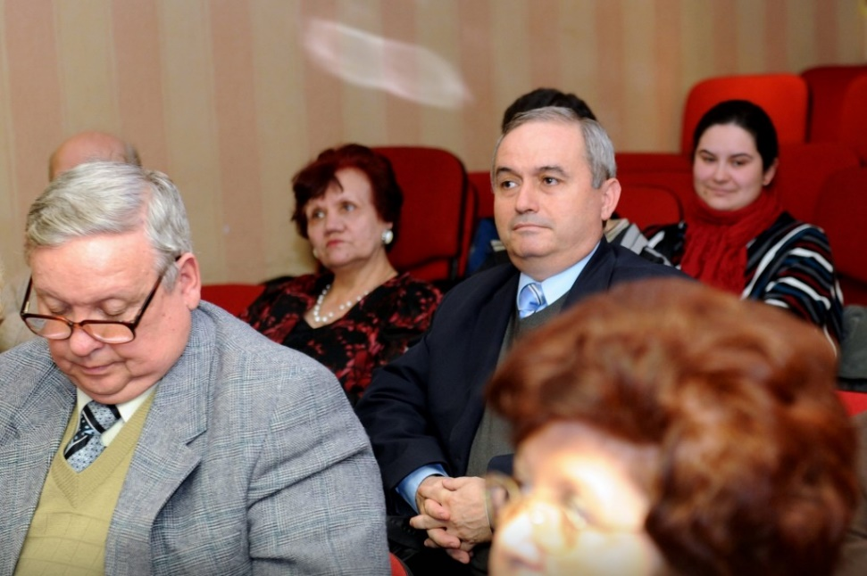

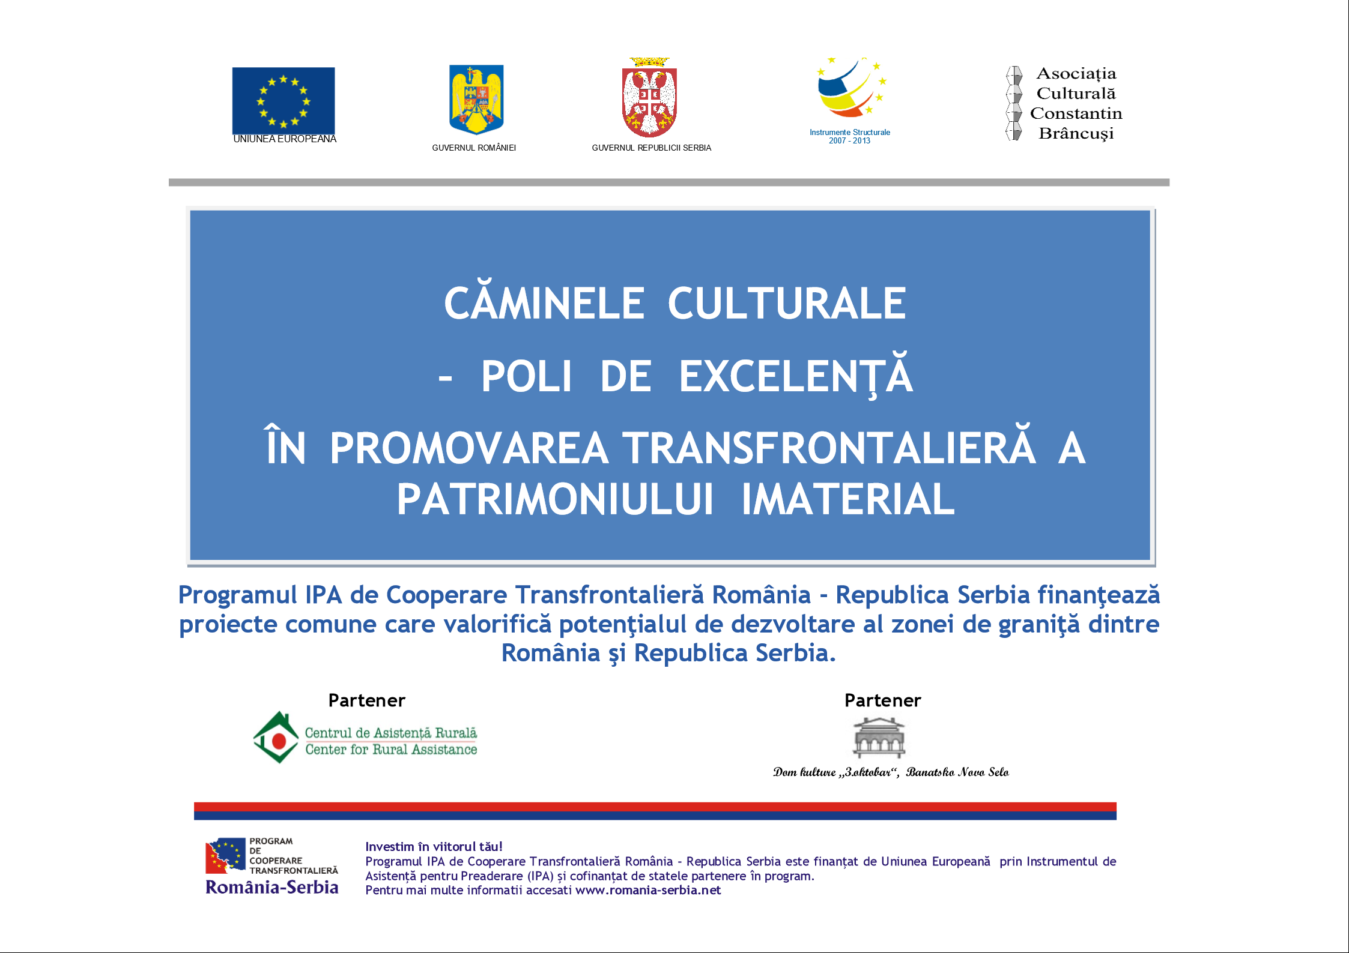
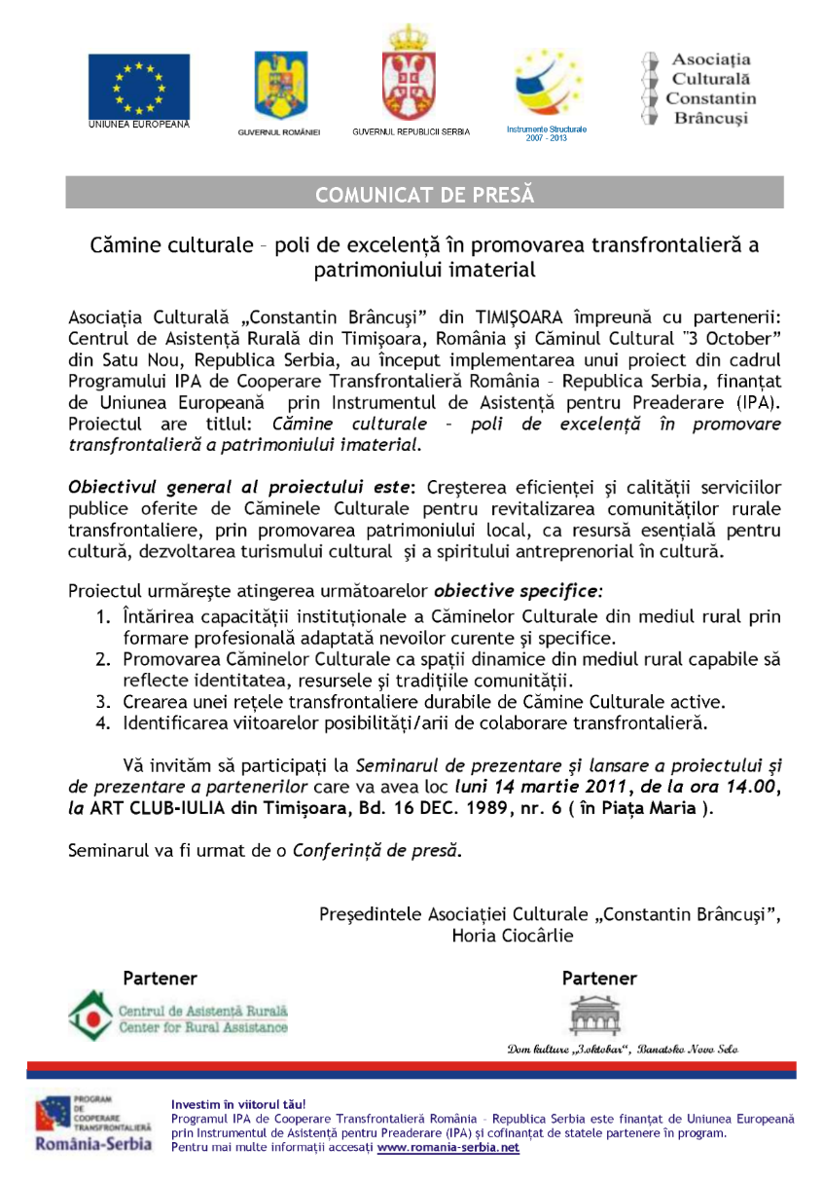

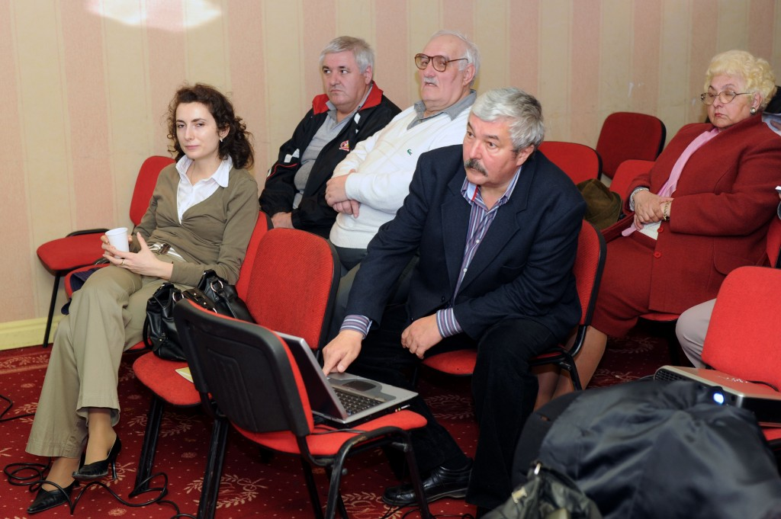

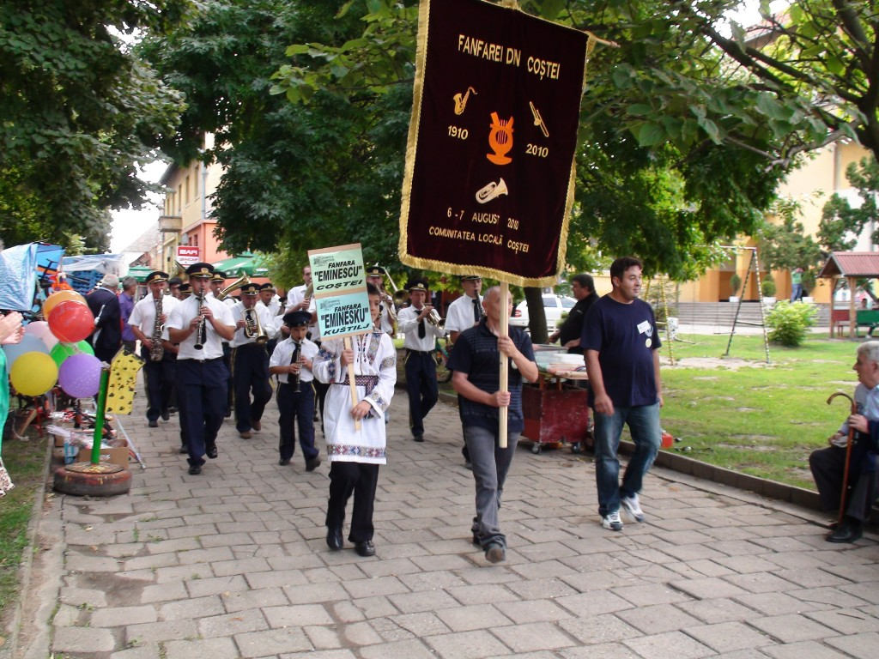

the implementation period (including extensions)
total funds spent/total funds contracted *100
indicators and level of achievement against targets set

